PARK-CLR

**Recognition within District Parks**

**Policy #1**

**Purpose**

The parks owned and operated by Chelan County PUD have become an important part of the local community. As such, individuals and groups currently, and well into the future, wish to acknowledge individuals for their contribution to the parks and the community in general. Additionally, family members may wish to acknowledge other members of their family. We have received numerous requests, from renaming an entire park to dedicating a park bench. In order to ensure a consistent and appropriate response to all requests this policy was created.

**Naming of parks**

All of the parks presently owned by the PUD are currently named appropriately. Changing the name of the park significantly impacts numerous individuals and governmental entities and the community. Therefore, it is the PUD’s policy not to re-name any existing parks.

**Naming of facilities within a park**

Requests to name or re-name a portion of the park, trail, facility or garden within the park will be considered when, and if, the following conditions are met:

**Names**

Names should provide some form of individual identity related to:

1. The geographic location of the facility.
2. An outstanding feature of the facility.
3. Commonly recognized historical event, group or individual.
4. An individual or group who contributed significantly to the acquisition or development of the park and/or individual facility.
5. An individual who provided an exceptional service in the interest of the park system or community as a whole.
   * The contributions of an individual or group must be well documented and broadly acknowledged within the community.

**Submission Process**

1. All parties wishing to propose names for gardens, trails, facilities or memorials must submit a written proposal providing sufficient information as to how the proposed name satisfies the criteria of the park naming guidelines.
2. Adequate historical or descriptive information shall be provided to validate the proposed name, so that staff may have a clear understanding and appreciation for the request.
3. A proposal to commemorate an individual must contain evidence of support for the name and its application. Such evidence can be letters from local residents, government officials and/or community leaders. The proposal may also include petitions containing signatures of local citizens.
4. When naming after a deceased person or persons, written documentation of approval by next of kin to be honored (if available/possible) is required as part of the proposal.
5. The Parks Manager will review the proposal for adherence to the stated criteria and authentication of statements relative to the contributions of an individual.
6. If the request is incomplete, Parks staff will contact the applicant, in writing, and provide them with the opportunity to resubmit a revised request.

**Renaming**

1. The intent of naming is for permanent recognition. The renaming of parks facilities is strongly discouraged. It is recommended that efforts to change a name be subject to the most critical examination so as not to diminish the original justification for the name or discount the value of the prior contributors.
2. Only those facilities named for geographic location or outstanding feature should be considered for renaming.
3. Facilities named after individuals should never be changed unless it is found that the individual’s personal character is or was such that the continued use of their name for a park or facility would not be in the best interest of the community.

**Naming Process**

1. The PUD’s Director of Parks (Director) will receive written naming applications for review.
2. For an individual (excluding historically significant individuals) to be considered, that person must have contributed significantly to the acquisition or development of the park or facility, to the park system overall, or to the community as a whole. The recommended name must be accompanied by a biographical sketch which shall provide evidence of contributions to the community, park, facility, or park system overall.
3. If the Director determines a naming application meets the recognition policy criteria, then a public notice of the recommended qualifying name will occur twice during a 30-day period in the local newspaper. Citizen comments and recommendations must be in writing to the Director and be postmarked within the 30-day public notice period.
4. After the 30-day public notice period, the Director will submit the naming application for acceptance or rejection the PUD’s Board of Commissioners.

**Other Naming Alternatives**

1. Parks and facilities donated to the PUD can be named by deed restriction by the donor. The naming and acceptance of land is subject to approval by the PUD’s Board of Commissioners.
2. Facilities within parks (i.e., playfields, playgrounds, picnic shelters, etc.) can be named separately from the parks and facilities they are in, subject to the general approval process described throughout the policy.

**Individual Recognition**

Recognition of individuals such as family members will only be allowed through one of two programs.

The first program is the park bench program. This program allows a family, company, or individual to purchase a park bench and dedicate it to an individual. There are two types of benches that can be purchased. The first is the current PUD’s standard park bench. The second is an artist created bench that has been approved by the Parks Manager. In either case, a plaque recognizing the individual will be placed as determined by the Parks Manager near the bench.

The second program is the dedicated plaque program. A plaque will be placed in a uniquely dedicated location to such recognition within the park. Plaque dimensions may not exceed 17-inch by 17-inch.

Each program requires the dedicator to donate $500 toward the operation and maintenance of the park. The PUD will make every effort to preserve and protect any dedicated plaque or bench and will provide its regular standard of care and maintenance. If necessary, due to the repair of surrounding areas, construction or redesign of a park or facility, the plaque or bench may be relocated. Should the plaque or bench bedamaged due to vandalism or natural aging, the PUD will remove or repair the item at its sole discretion.

Donations and gifts are accepted and appreciated. If the dedication or gift includes the gift of a tree or other plant, the PUD Parks Department will provide its regular standard of landscape care for the tree or other plant. If the tree does not survive, PUD is not obligated to provide a replacement.

|  |  |
| --- | --- |
| **Formerly:** | New |
| **Effective Date:** | September 8, 2004 |
| **Date of Amendments:** | December 1, 2011 |

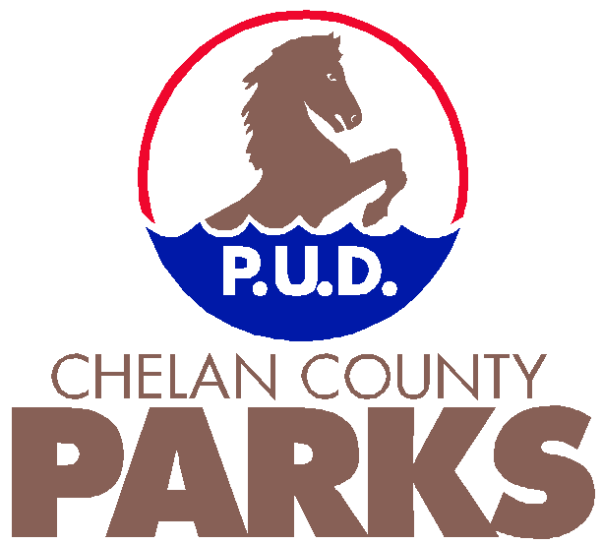

**Chelan County PUD Parks**

**NOMINATION FOR NAMING/DEDICATION OF FACILITIES**

DATE OF NOMINATION:

NOMINATOR:

ADDRESS:

PHONE:

RECOMMENDED NAME:

RECOMMENDED SITE:

IF A FAMILY MEMBER, WHAT IS THE RELATIONSHIP?

Please illustrate below the reasons for your nomination. Please be as complete as possible. Attach additional pages or supportive materials if needed to clarify the nomination.

Community-wide activities responsible for:

Local clubs or organizations served:

Schools attended:

Major benefit(s) to the history of “the local community:”

Why are you nominating this person?

Submit form to: Parks Department

Chelan County PUD

PO Box 1231

Wenatchee, WA 98807-1231

Phone: (509) 661-4551